Training and Support portal – add an article

Go to your region’s portal:

* Australia – [https://support.thomsonreuters.com.au](https://support.thomsonreuters.com.au/)
* New Zealand – <https://support.thomsonreuters.co.nz>
* Asia – <https://support.thomsonreuters.com.hk>
* Korea – <https://support.thomsonreuters.com.kr>
* MENA – <https://support.thomsonreuters.ae>

Click **Login** in the top-right, click **Premium Care Account**, and enter your username and password.

**Note:** if you don’t have a login for the Training and Support portal please contact Jessica FitzGerald.

# Create a new article

Hover over **Content**, then **Add Content**, and click **Alert**.

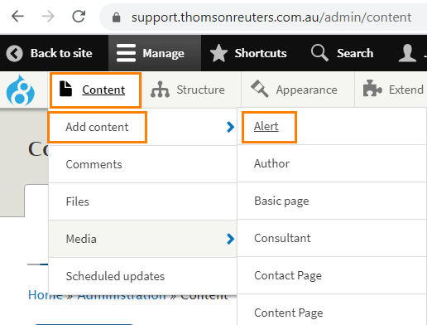

1. Title – the title should be no more than 2 lines, aiming for 10-20 words.
2. Region/Language – select Australia – this will display on the Australian site.
3. Teaser summary – a short intro copy which will appear on the “Updates and Alerts” listing page. The teaser summary should be a punchy and attention-grabbing line about your article.

**Note:** Under 200 characters including spaces. The Teaser does not appear on the article page itself, so if the teaser summary is more than 200 characters, it will not be seen.

1. Product – the product refers to the platform, e.g., Practical Law UK, new Westlaw (Australia), Westlaw AU, Westlaw Classic, etc.Ensure you choose the correct Product Number, or your article will not display. (Full list at end.)

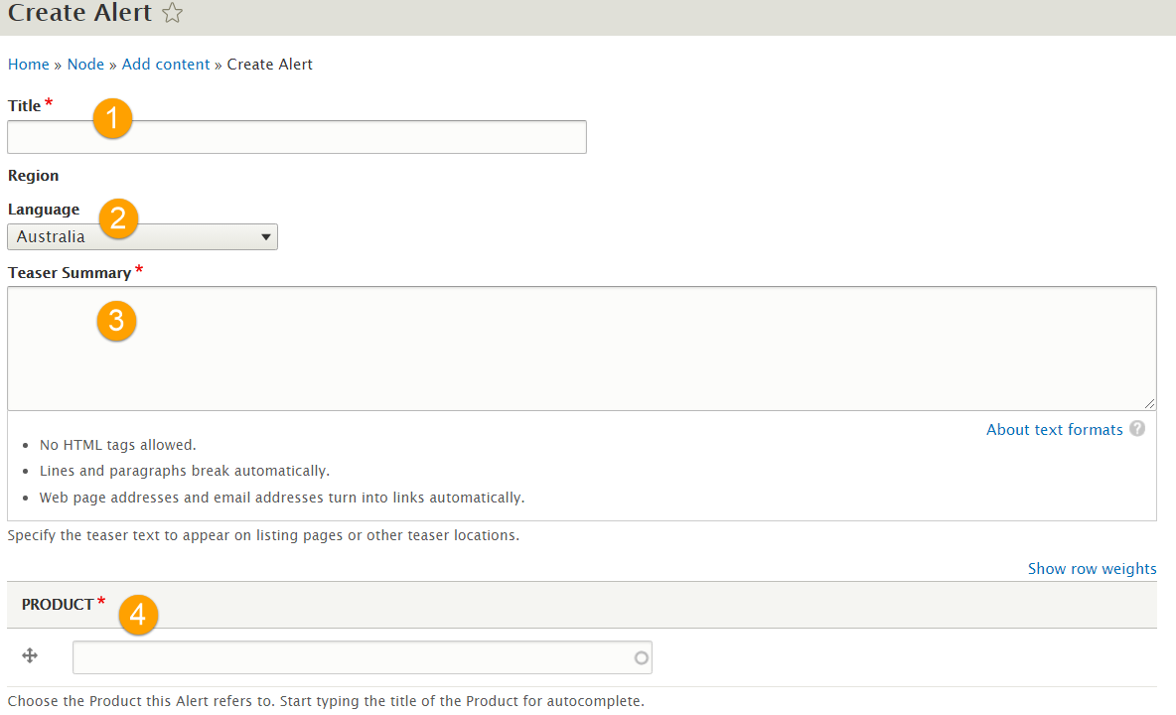

1. Intro – the intro should be 1 paragraph (around 50 words). The intro is separate from the main body of your article which you will need to add in a separate section below.

**Note:** Remove formatting from pasted text by highlighting the text and clicking **Tx**.

1. Date and time – insert date and time – this will be pre-filled.
2. Related content – displays other content on the portal below your article. Feel free to leave this blank.

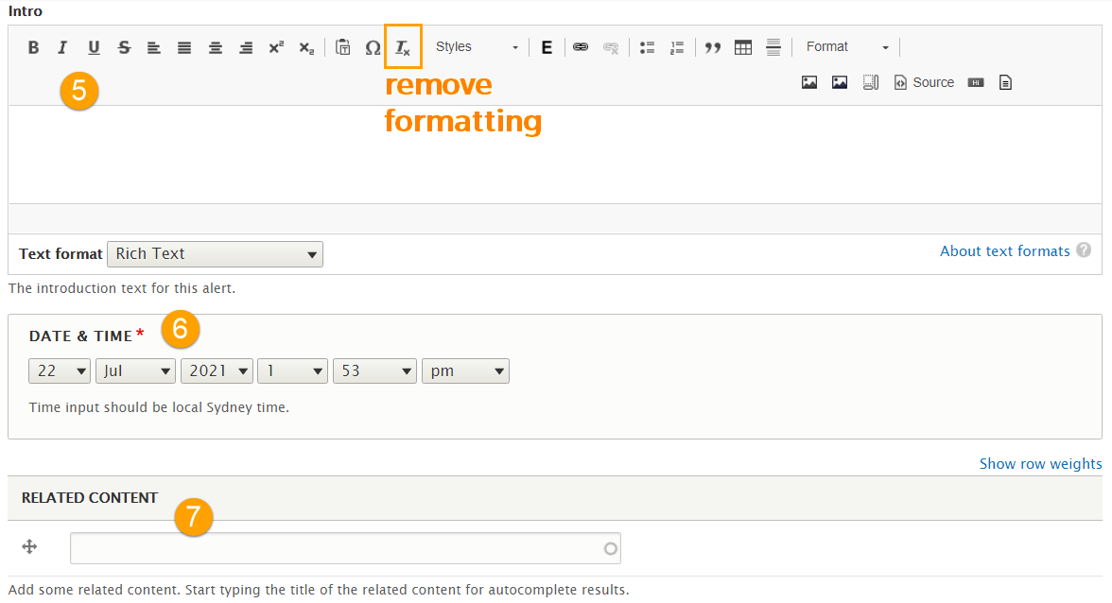

1. Update type – choose Content Enhancements.
2. Tags – Choose up to 3 tags relating to your practice area or product name from the list.  
   Hold the Ctrl button on your keyboard and use your mouse to click multiple tags.

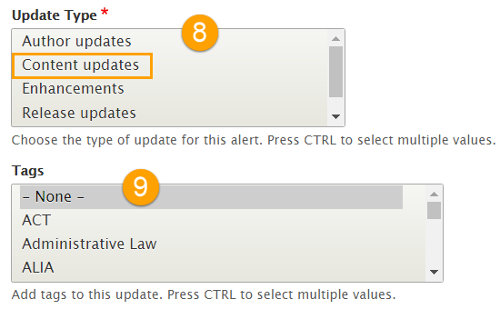

1. **Body** – This is where you will enter the main part of your article. Choose the paragraph type **Body** and click **Add Paragraph**. Enter your text in the body window.

**Note:** Remove formatting from pasted text by highlighting the text and clicking **Tx**.

**Note 2**: Do not add images into the body text. See below instructions to add an image.

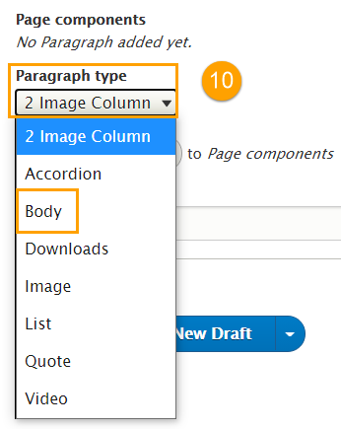

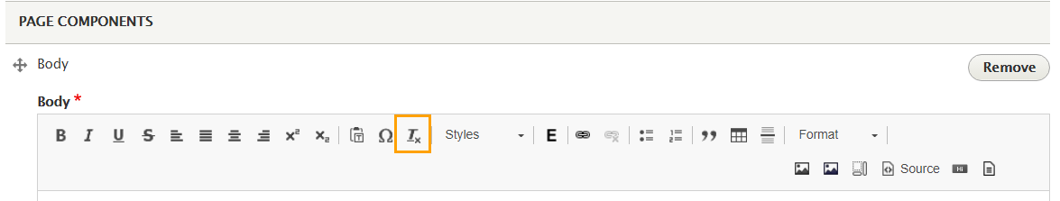

1. Author – Article author. Start typing your name and choose from the list.  
   If you aren’t in the list, please let Jessica FitzGerald know – you will need to provide your name, title, brief bio, and a photo/headshot.
2. Save as Draft or Publish your article.

* To save as a draft, untick the box next to Published. Click **Save and create new draft**.
* To publish your article, ensure the box next to Publish is ticked. Click **Save and publish** from the drop-down menu.

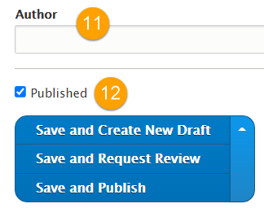

Finally, review your published article!

If you spot a typo or error, you can click **New draft** at the top of the screen to return to the editing page.

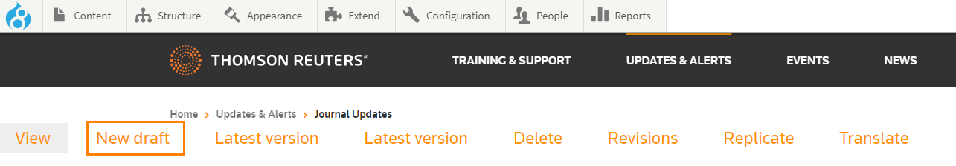

|  |  |  |
| --- | --- | --- |
| TITLE | SITE | PRODUCT No. |
| OnePass | Asia | 11726 |
| Practical Law | Asia | 12886 |
| Practical Law UK | Asia | 12881 |
| ProView | Asia | 11716 |
| Single Sign On | Asia | 11731 |
| Westlaw Asia (new) | Asia | 12396 |
| Westlaw China | Asia | 19881 |
| Westlaw Classic | Asia | 11711 |
| Westlaw Middle East | Asia | 20221 |
| Westlaw UK | Asia | 11721 |
| BigRedSky | Australia | 4541 |
| Checkpoint | Australia | 4546 |
| Cleardocs | Australia | 5091 |
| Connect4 | Australia | 4551 |
| Contract Express | Australia | 307 |
| cvMail | Australia | 4536 |
| Data Privacy Advisor | Australia | 9686 |
| HighQ | Australia | 12766 |
| Infinitylaw | Australia | 1979 |
| Legal Tracker | Australia | 2019 |
| My Account | Australia | 4856 |
| new Westlaw (Australia) | Australia | 7416 |
| OnePass | Australia | 2014 |
| Pay Per View | Australia | 11426 |
| Practical Law Australia | Australia | 305 |
| Practical Law UK | Australia | 12881 |
| ProView | Australia | 308 |
| Single Sign On | Australia | 11441 |
| Softdocs | Australia | 306 |
| Training | Australia | 4931 |
| Westlaw AU | Australia | 2021 |
| Westlaw Classic | Australia | 2054 |
| Westlaw (New) LEAP customers | Australia | 18386 |
| Westlaw UK | Australia | 4236 |
| LAWnB | Korea | 15946 |
| Practical Law | Korea | 15941 |
| Practical Law UK | Korea | 14836 |
| Westlaw Asia (new) | Korea | 15926 |
| Westlaw Classic | Korea | 15931 |
| Westlaw Japan | Korea | 15951 |
| Westlaw UK | Korea | 15936 |
| OnePass | MENA | 23626 |
| Practical Law | MENA | 23496 |
| Single Sign On | MENA | 23521 |
| Westlaw Classic | MENA | 23631 |
| Westlaw Middle East | MENA | 23476 |
| Westlaw UK | MENA | 23506 |
| Checkpoint | New Zealand | 7321 |
| Cleardocs | New Zealand | 5091 |
| Contract Express | New Zealand | 307 |
| Data Privacy Advisor | New Zealand | 9686 |
| Infinitylaw | New Zealand | 1979 |
| My Account | New Zealand | 4856 |
| new Westlaw (New Zealand) | New Zealand | 7446 |
| OnePass | New Zealand | 2014 |
| Pay Per View | New Zealand | 11431 |
| Practical Law Australia (incl. NZ Resource Centre) | New Zealand | 305 |
| Practical Law UK | New Zealand | 12881 |
| ProView | New Zealand | 22031 |
| Single Sign On | New Zealand | 11436 |
| Training | New Zealand | 4931 |
| Westlaw Classic | New Zealand | 2054 |
| Westlaw NZ | New Zealand | 2022 |
| Westlaw UK | New Zealand | 4236 |