Practical Law UK
Current Awareness Alert
To help you stay on top of the latest legal developments for specific topics and practice areas in Practical you can create a current awareness email alert.

Setting up an alert is simple and quick an involves a two-step process:
1) Select the required Practice Areas
2) Schedule the Alert
You can set up as many alerts as required and have an alert for each practice area, or an alert covering a practice area which includes related sub-topics.

Create an Alert
- Once signed into Practical Law, you can set up an alert by clicking Alerts on the top right corner of the screen.

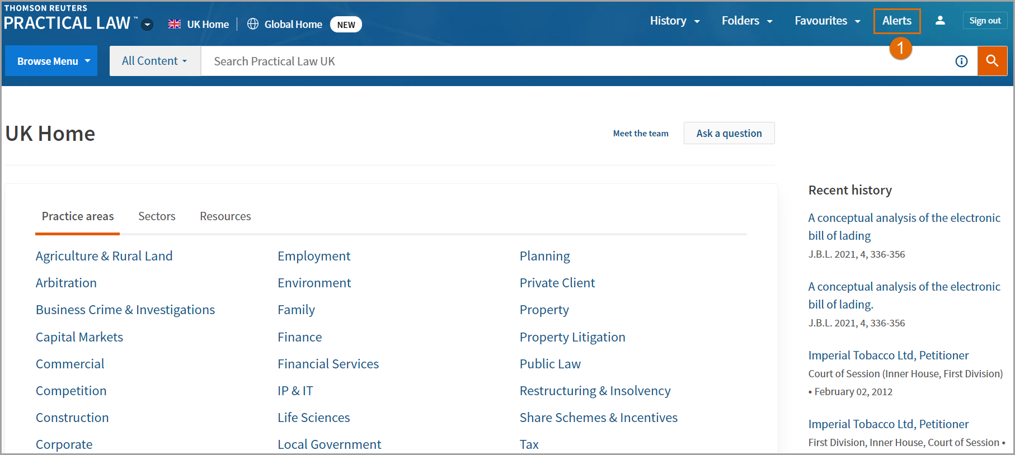

- Click the Create Alert button.
- Select Practical Law Current Awareness Alert

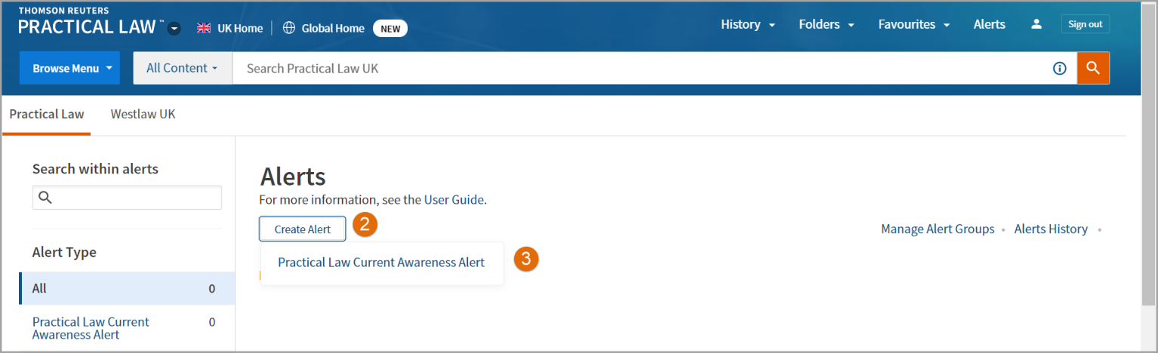

- Click on the plus icon next to a practice area to add all topics within that area into your alert.
You can also click on the name of the practice area to select specific topics within that area.

- All practice areas selected will now appear under Your Selections.

- Schedule Alert: allows you to choose the frequency, end date, and when to receive the alert.
Frequency: you can choose to receive your alert Daily, on Weekdays, Weekly, Fortnightly and Monthly.
End Date: you can specify a date on which the alert will expire.
Alert even if there are no results: tick this box if you want confirmation that the Alert ran, even if there is no new content for your topic(s).
Alert At This Time: specify the time zone and time most convenient to receive your email alert.

- Then click on Create Alert.

